Mulesoft Anypoint Platform
Experiment 6
Create a Mule project to create a table in MySQL using the Database Connector in Anypoint Studio.
Solution:
In this experiment, we will create a Mule application that interacts with a MySQL database using MuleSoft’s Database module. The objective is to define a flow that executes a Data Definition Language (DDL) command to create a new table inside a MySQL database.
Steps:
- First open Mysql workbench:
  - In this select the connection if not create a local instance
  - 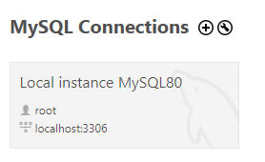
  - Connect to localhost by giving the password.
  - 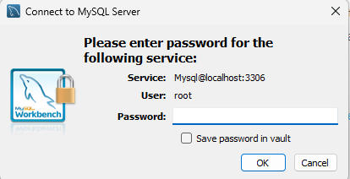
  - 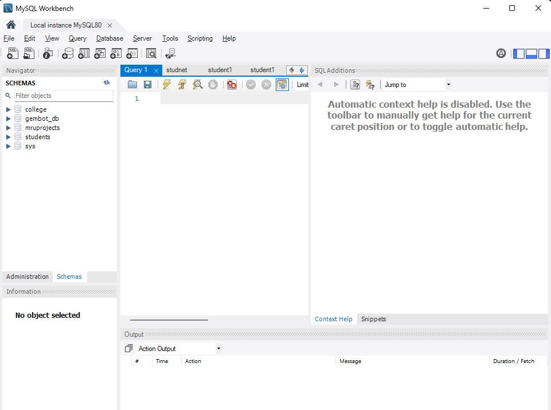
  - In this page create a database called students and click enter later,
- Open Anypoint Studio and create a new Mule project.
  - Go to File ➜ New ➜ Mule Project
  - Name the project: sqlproject
  - Click finish.
- In the Mule Palette, expand the Database module. If it is not visible, click Add Modules and search for Database.
- 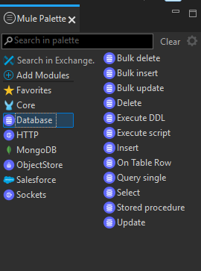
- Drag an HTTP Listener component to the canvas.
  - Set the path as /createtable
  - Configure the listener:
    - Host: 0.0.0.0
    - Port: 8081
- Drag a Database - Execute DDL component next to the HTTP Listener.
  - 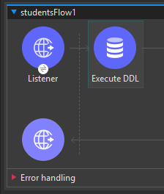
- Click on the Database component and set up a global configuration:
  - Driver Class Name: com.mysql.cj.jdbc.Driver
  - Host: localhost
  - Port: 3306
  - User: root
  - Password: your_password
  - Database: your_database_name
  - Click Test Connection to ensure it’s successful
  - 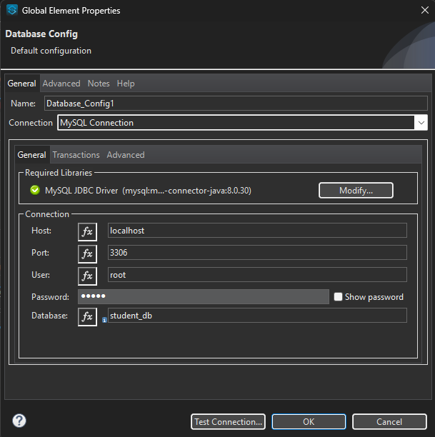
- After connection is successful click ok.
- In the SQL Query section of the Execute DDL component, write:
- create table student1(sno varchar(20), sname varchar(20))
- Add a transform message and set the code to /json and give a message for Table created successfully. 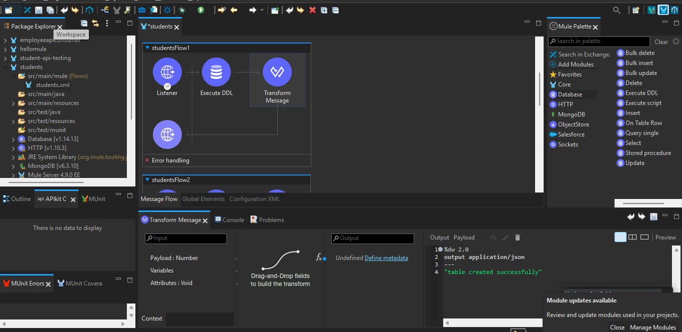
- Save the project and click Run.
- Open your browser or Postman and hit:
  - http://localhost:8081/createtable
  - 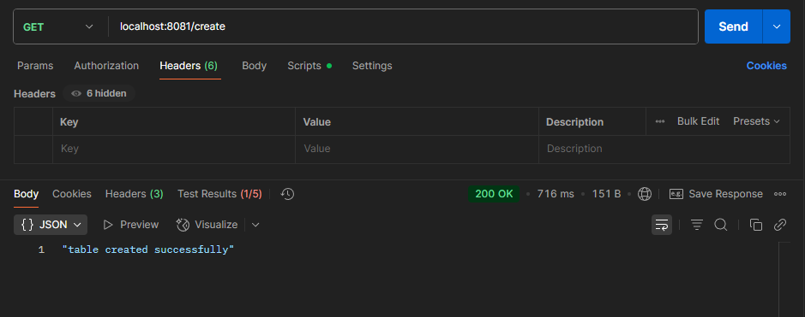
- You have created the Table student in the database successfully.

